POT ________

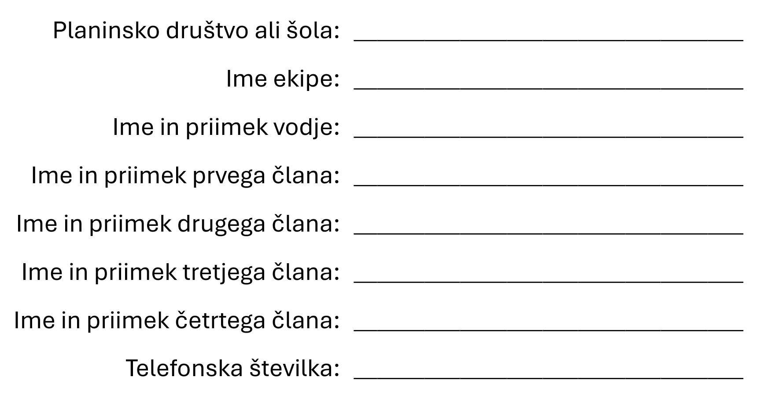

POT ________

